How to access OneNote

1. To access the OneNote for 4th years, you need to look for an email from Miss Swindells (for Miss Swindells’ classes) or Mrs Jolliffe (her class and Mr Seal’s classes) inviting you. The OneNote is called **iGCSE History (B_C) 2019-2020**. An example of what the email will look like is below.

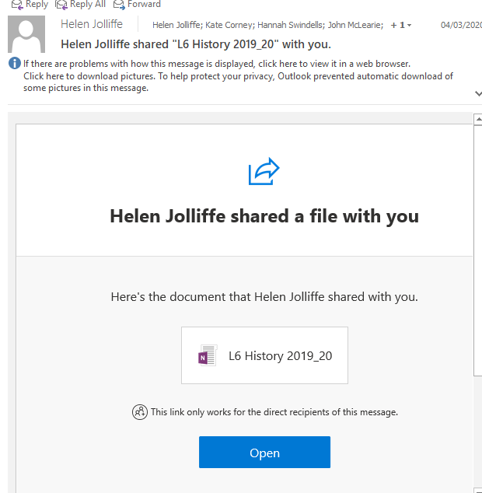

1. The first time you access OneNote has to be through this email, but after this, you can access it by going to [www.portal.office.com](http://www.portal.office.com) at home.
2. You then need to select the ‘OneNote’ app.

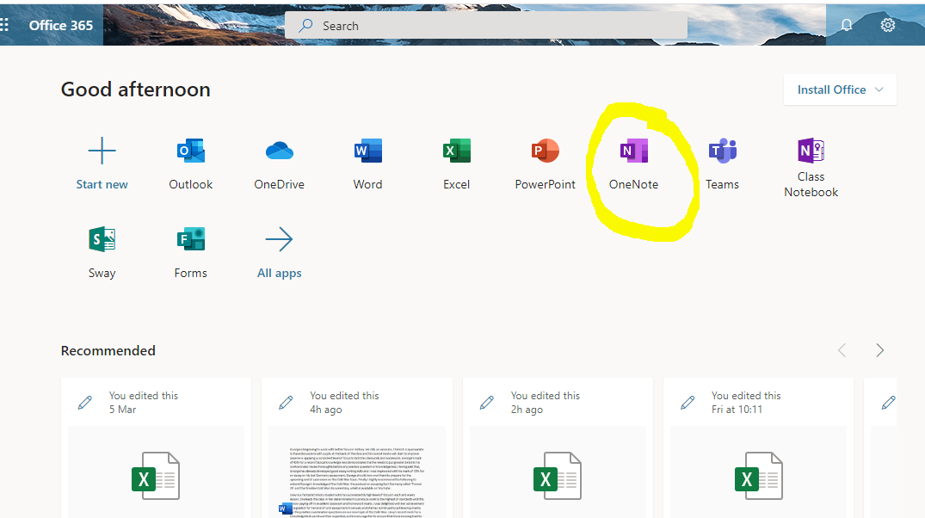

1. This will take you to a drop-down page, click the OneNote you wish to view: iGCSE History (B_C) 2019-2021
2. Once on here there are two main areas that are relevant to you at home:
   1. **Content Library**

In the content library, you see 2 tabs: Paper 1 and Paper 2. Click on Paper 1 (this is the exam paper you have been preparing for this year).

Then in the Paper 1 area, you will see that are three sections:

* + - Paper 1 Exam advice: this has guidance sheets for each type of question on the exam. We highly recommend that you use these to help you write practice exam questions.
    - Germany: This contains all the PPTS and useful resources for the Germany paper, and is broken down into the 5 different topics. You can use this section for revision.
    - Cold War: This contains your PPTS and useful resources for the Cold War so far... Miss Swindells will continue to update this section as we move through the course. If your firefly task asks you to look through a PPT, you will find it here.

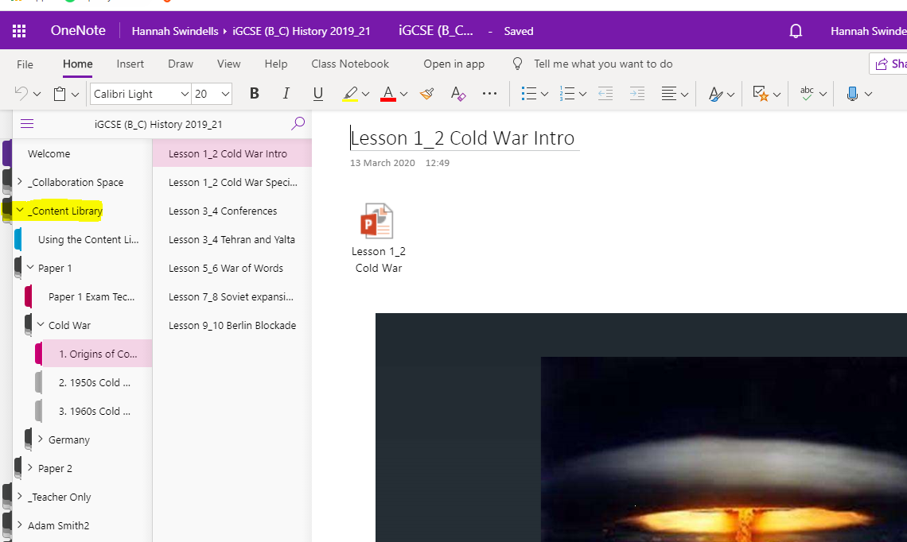

* 1. **Pupil areas.** These will be the most important ones for you during the event of a school closure. You have your own private section, which only you and Miss Swindells/your teacher can see. When you are set a practice exam question, your teacher will create a tab in the **CLASS NOTES** sections, and you will be expected to type it in that tab. You can type directly into OneNote and don’t need to save/back it up (it does this automatically through the cloud).

Miss Swindells has created a tab in this called ‘TEST’. Please find this tab and type your full name into it so you teacher can check that you can access OneNote.

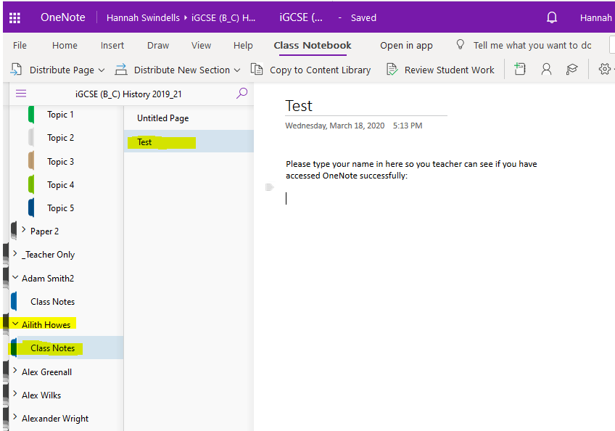

Your teacher will then be able to mark your work directly on this page.

If you cannot find the email inviting you to join, or you get stuck, please email Miss Swindells who is on hand to help: [hswindells@churcherscollege.com](mailto:hswindells@churcherscollege.com)